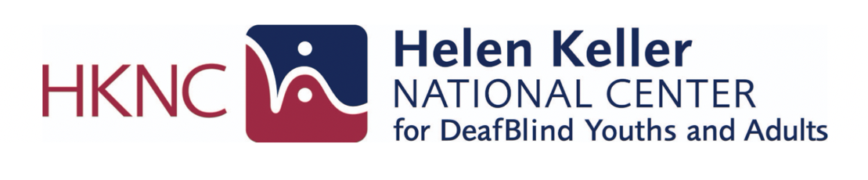

Protactile (PT): An Introduction

What is Protactile?
Protactile (PT) is an emerging language and philosophy deeloped by and within the DeafBlind community. Grounded in touch, Protactile emphasizes direct communication, shared experiences, and accessing information through tactile interaction rather than relying primarily on vision or hearing.
PT is more than a communication method. It reflects a way of interacting with the world that values touch as a primary source of information, connection, and learning.

A Community-Driven Language
Protactile emerged through the lived experiences of DeafBlind individuals seeking more direct and effective ways to communicate with one another. As members of the DeafBlind community experimented with new tactile strategies and shared experiences, Protactile continued to evolve. Ongoing research has documented its development as an emerging language with its own structure and linguistic features.

Core Concepts
Protactile is founded on several key ideas:
- Touch is the primary source of information.
- Communication occurs through constant tactile connection and reciprocity.
- Meaning is developed through shared tactile experiences and direct interaction.
- DeafBlind individuals communicate directly with one another whenever possible.
- The language continues to evolve through use within the DeafBlind community.

Why is Protactile Important?
Protactile provides opportunities for DeafBlind individuals to:
- Access environmental and social information through touch.
- Participate more fully in conversations and shared experiences.
- Develop direct communication with other DeafBlind individuals.
- Build community, identity, and connection through tactile interaction.

Learn More
The following resources provide additional information about Protactile philosophy, language development, research, and community.

Books & Articles
- Against Access – John Lee Clark
- Touch the Future: A Manifesto in Essays – John Lee Clark (2023)
- Distantism – John Lee Clark
- DeafBlind Communities May Be Creating a New Language of Touch – Andrew Leland, The New Yorker (2022)
- Becoming Protactile: Interactional Foundations of Protactile Language Development and Language Emergence – Jenny C. Lu, Jelica Nuccio, Halene Anderson, & Terra Edwards (2024)
- The Medium of Intersubjectivity – Terra Edwards (2024)

Videos
- American Masters: Protactile – A Language of Touch (PBS)

Organizations & Websites
- Protactile Research Network
- Protactile Connects
- DeafBlind Kids
- Tactile Communications
  - Email: info@tactilecommunications.org

Training Resources
- Protactile Language Interpreting Modules (DCMP)

Note:
Protactile is an emerging language that continues to evolve through the experiences, practices, and contributions of the DeafBlind community. The resources provided above represent a selection of publications, organizations, and training materials for individuals interested in learning more about Protactile philosophy, language development, and current research.

