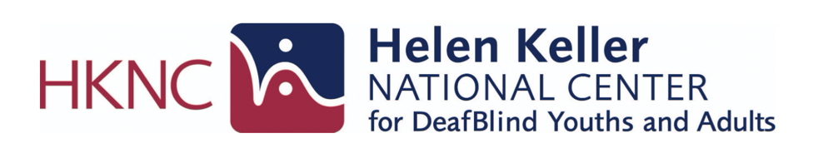

National Agencies and Programs Supporting DeafBlind Individuals and Families

Below is a list of resources that may be helpful for DeafBlind people and their family members/loved ones. This list is not exhaustive.
Find and contact your regional representative here for state-specific resources and please register on our National Registry

Table of Contents:
- National Training, Technical Assistance and Adult Services
- Advocacy and Community Organizations
- Medical and Condition Specific Organizations
- Family, Youth and Early Intervention Resources
- Independent Living and Local Support Organizations

National Training, Technical Assistance and Adult Services
- Helen Keller National Center
  - National center providing training, vocational rehabilitation and technical assistance for youth and adults who are DeafBlind.
- iCanConnect
  - Provides free communication technology, equipment and training to people with combined hearing and vision loss who meet eligibility Requirements
- Lighthouse Guild
  - Vision rehabilitation services including healthcare, technology training, and support programs for people with vision loss, including DeafBlind individuals.
- Perkins
  - Education, resources, and professional training focused on children and young adults who are blind or DeafBlind.

- National Federation of the Blind: DeafBlind Resources
  - Advocacy, information, and community resources specific to blind and DeafBlind individuals.

Advocacy and Community Organizations

- American Association of the DeafBlind
  - National membership organization promoting community, leadership, and advocacy led by deafblind individuals.
- DeafBlind Citizens in Action
  - Advocacy organization focused on civil rights, accessibility, and policy impacting DeafBlind people.
- National Family Association for Deaf Blind
  - Family-led support network providing connection, resources, and advocacy for families of DeafBlind individuals.
- Hands and Voices
  - Parent-driven organization supporting families of children who are deaf or hard of hearing, including those with additional disabilities.

Medical and Condition-Specific Organizations
- Charge Syndrome Foundation
  - Education, research, and family support related to CHARGE syndrome.
- Usher Syndrome Coalition
  - Resources, research updates, and community connection for individuals with Usher syndrome.

Family, Youth and Early Intervention Resources

- National Center on Deaf-Blindness
  - A national technical assistance center that supports states, educators, and families in improving services and outcomes for children and youth who are DeafBlind through training, research, and practical resources.
- National List of State DeafBlind Projects (For ages 0-21)
  - State programs that provide early intervention, educational support, and technical assistance for children and youth who are DeafBlind.

Independent Living and Local Support Navigation
- Directory of Centers for Independent Living
  - Nationwide directory of community-based organizations that support independent living for people with disabilities.

