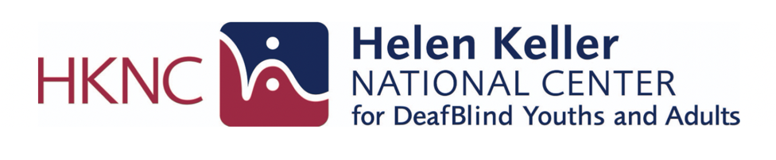

National Agencies and Programs Supporting DeafBlind Individuals and Families National Agencies and Programs Supporting DeafBlind Individuals and Families

Below is a list of resources that may be helpful for DeafBlind people and their family members/loved ones. This list is not exhaustive.
Find and contact your regional representative here for state-specific resources and please register on our National Registry

Table of Contents:
- National Training, Technical Assistance and Adult Services
- Advocacy and Community Organizations
- Medical and Condition Specific Organizations
- Family, Youth and Early Intervention Resources
- Independent Living and Local Support Organizations

National Training, Technical Assistance and Adult ServicesNational Training, Technical Assistance and Adult Services
- Helen Keller National Center
  - National center providing training, vocational rehabilitation and technical assistance for youth and adults who are DeafBlind.
- iCanConnect
  - Provides free communication technology, equipment and training to people with combined hearing and vision loss who meet eligibility Requirements
- Lighthouse Guild
  - Vision rehabilitation services including healthcare, technology training, and support programs for people with vision loss, including DeafBlind individuals.
- Perkins
  - Education, resources, and professional training focused on children and young adults who are blind or DeafBlind.

- National Federation of the Blind: DeafBlind Resources
  - Advocacy, information, and community resources specific to blind and DeafBlind individuals.

Advocacy and Community OrganizationsAdvocacy and Community Organizations

- American Association of the DeafBlind
  - National membership organization promoting community, leadership, and advocacy led by deafblind individuals.
- DeafBlind Citizens in Action
  - Advocacy organization focused on civil rights, accessibility, and policy impacting DeafBlind people.
- National Family Association for Deaf Blind
  - Family-led support network providing connection, resources, and advocacy for families of DeafBlind individuals.
- Hands and Voices
  - Parent-driven organization supporting families of children who are deaf or hard of hearing, including those with additional disabilities.

Medical and Condition-Specific OrganizationsMedical and Condition-Specific Organizations
- Charge Syndrome Foundation
  - Education, research, and family support related to CHARGE syndrome.
- Usher Syndrome Coalition
  - Resources, research updates, and community connection for individuals with Usher syndrome.

Family, Youth and Early Intervention ResourcesFamily, Youth and Early Intervention Resources

- National Center on Deaf-Blindness
  - A national technical assistance and information dissemination center that works with state deafblind projects and national partners to improve services, educational results, and quality of life for children who are deafblind. NCDB's website has extensive resources for families, educators, and other service providers on educating and supporting children and youth who are deafblind.
- National List of State DeafBlind Projects (For ages 0-21)
  - State programs that provide early intervention, educational support, and technical assistance for children and youth who are DeafBlind.

Independent Living and Local Support NavigationIndependent Living and Local Support Navigation
- Directory of Centers for Independent Living
  - Nationwide directory of community-based organizations that support independent living for people with disabilities.

