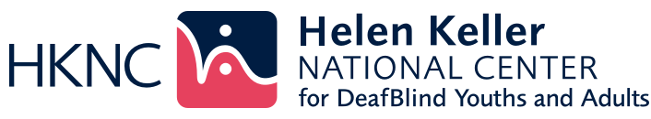
Summer Youth Vocational Program (SYVP) 2026
Empowering Youth Through STEAM, Surfing, and Self-Discovery
Dates: July 6 to July 31, 2026 | Location: Helen Keller National Center, New York

Ready to discover what you're capable of? HKNC's Summer Youth Vocational Program (SYVP) helps youth explore careers through hands-on work experience at multiple job sites. You'll dive into STEAM projects, experience activities like adaptive surfing, and develop self-advocacy skills, all while discovering your strengths. SYVP is about exploration and possibility, giving you the confidence and skills to shape your own future.

Program Highlights
- STEAM Activities: Engage in hands-on science, technology, engineering, arts, and math projects

- Adaptive Surfing: Combine physical activity with social-emotional learning, self-determination, and career awareness

- Motivational Speakers: Hear inspiring stories from leaders and changemakers

- Self-Empowerment & Advocacy Workshops: Build confidence, communication, and self-advocacy skills

- Work Experience: Participate in real-world job tasks and workplace readiness training

- Camp-Ability with Lauren Lieberman: learn to set goals by exploring the outdoors through inclusive adventure and nature-based learning

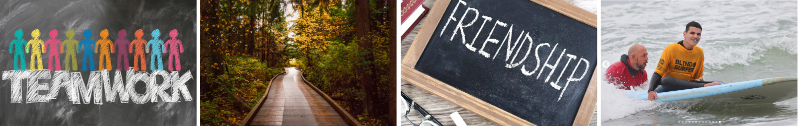

Learn more about Adaptive Surfing at SurfForAll.org

www.HelenKeller.org/hknc/youth-programs

