# HKNC Logo

# Tips for Communicating with DeafBlind Individuals via Sign Language

People who are DeafBlind use different methods to communicate including sign language, speech, text and Protactile language. Once you identify the person’s preferred method of communication you must identify the necessary accommodations to access that method of communication.

Each DeafBlind person is unique. One must check in with the individual to determine what accommodations they require to access their preferred mode of communication.

## Visual Sign Language:

A person sitting in a chair infant of a black screen signing. A second man is seated at a distance facing the signer

 Two woman seated facing one another approximately 10 inches apart. One woman is signing. 



### Distance, Signing Space and Pace

* A person with restricted visual fields (i.e., retinitis pigmentosa) may require signs to be presented at a distance and in a small signing space to keep the signs within their visual fields.
* A person with a central vision loss (i.e., macular degeneration) may prefer sign presented close.
* Pace: people may prefer fingerspelling to be presented at a slower pace and may require repetition.

### Environmental Considerations

* Ensure there is sufficient lighting
* Avoid glare (i.e., don’t stand in front of a window)
* Consider background: Solid backgrounds that are contrasting colors to the signer’s skin tone. Black or dark blue for people with paler skin and tan or light blue for people with darker skin color. Avoid white backgrounds as this can cause glare and sometimes be painful.

### Personal Considerations:

* Signer should wear clothing that is of contrasting color to their skin tone (no white) Clothing should be solid colored
* Avoid bulky jewelry or bright long nails as this can be visually distracting.

### Tracking:

Tracking is a method where the receiver places their hands on the signer’s wrists to keep the signs within their visual fields.

## Tactile Sign Language:

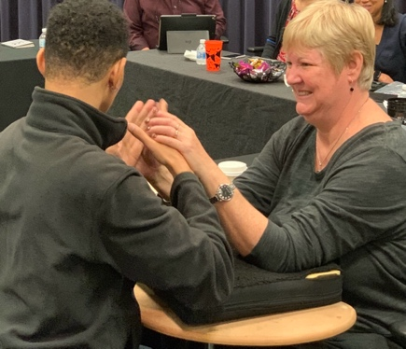

Tactile sign language is a method of receiving sign language by placing one’s hands over the hand of a communication partner to feel shape and movement. The individual may prefer a one- or two-handed approach to tactile signing. Because so much of American Sign Language (ASL) relies on body language, tactile sign language needs to be modified to convey this information. Examples include conveying facial expressions, tone of the message, head movements, shoulder raises, mouth morphemes and movements of the body in sign.

If a person is utilizing a one-hand approach, the signer must take into consideration signs that are not symmetrical. For example, the sign for “garage”. The signer must modify the sign to ensure that the individual has contact with the non-dominant hand. Seating and supports are also vital as tactile sign language can be tolling on the body. A table, pillow and adjustable chairs may be needed.

For more information, please go to the [HKNC Learning Center](https://www.helenkeller.org/professional-training/) where you can find several courses and resources on communication methods used by individuals who are DeafBlind and so much more.