

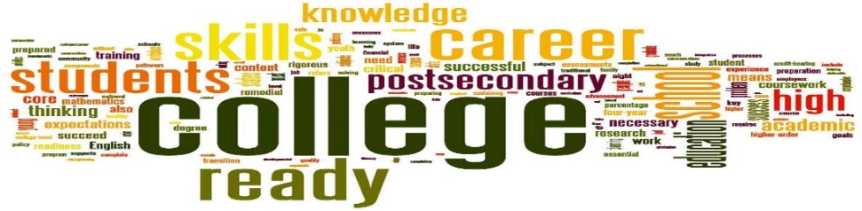

**College Bound Program: A structured college prep program**

*The* ***HKNC College Bound Program*** *is an immersive program targeted on preparing youth for college. There is a focus on the apartment and dormitory experience, the skills for independent living, orientation & mobility, classroom accommodations, internship accommodations* and work-study exploration.

***Learn how to:***

* + Prepare for college
  + Work with the college accessibility office
  + Manage classes and college life
  + Enhance college skills related to budgeting, accessing Google docs, formatting and saving papers, web browsing strategies
  + Work on actual college applications
  + Protect your personal identity
  + Manage social media
  + Optimize your classroom experience
  + Request interpreting supports
  + Develop self-advocacy
  + Be prepared for emergencies

Learn about: a*vailable transportation options, find how to navigate your college campus, alerting devices/systems, simple cooking, organizational systems, labelling techniques, safe travel techniques, general safety, interviewing skills, time management, on-line food shopping and using customer service, accessing blackboard and canvas, internet safety, and e-books.*

*The program is tailored to meet your needs and covers 23 important college skills!*

*Learn in group classes with HS and college peers and in one-on-one classes.*

**When: July 7- July 11, 2025 Application deadline is May 2, 2025**

**This program can also be tailored to one-week or two-weeks during school breaks such as fall, winter, and spring and at other times that match your schedule.**

**Where:** **Helen Keller National Center - 141 Middle Neck Road, Sands Point, NY 11050**

Admission will be on a first come/first served basis.

***Request an application from your Regional Representative***

<https://www.helenkeller.org/hknc/nationwide-services>

***or Dora Carney (Admissions Coordinator) at dcarney@helenkeller.org***