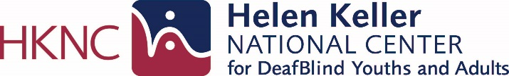

SUMMER ASSESSMENT PROGRAM

This summer empower yourself with knowledge, skills
and tools to determine your own future

Come join us at HKNC this summer! Are you 16 years of age or older? Currently attending high school? Would you like to participate in career exploration or in identifying your next steps to college? Interested in meeting and socializing with others who are DeafBlind? Interested in working and learning together with peers? Interested in actual hands-on time with the latest advances in technology for gaining access to information and connecting to others?

The Summer Assessment Program will offer will provide you with opportunities to gain knowledge and experience in the following areas:
- Career and Job Exploration
- Worksite Tours
- Workplace Readiness Skills
- Counseling on Post-Secondary Education
- Adaptive Technology
- Self-advocacy - Facilitate IEP
- Orientation & Mobility
- Low Vision and Audiology
- Communication

You can choose to join group classes such as Emergency Preparedness, ASL, physical fitness and Advocacy in the DeafBlind World. HKNC offers you a friendly, fun and unique learning environment. Come learn what Vocational Rehabilitation is all about and what options exist for achieving your definition of success! Enjoy the New York experience and the surrounding areas including beautiful Long Island with its world-class beaches, parks and malls. Your unique summer experience is waiting for you!

Come join your peers ages 16-24 from around the country to identify goals and develop an action plan for your last years of High School. Prepare for college, a trade school or work.

Assessments are offered for four, six & eight weeks in June, July and August, 2024

Contact your Regional Representative to find out how you can apply:

https://www.helenkeller.org/hknc/nationwide-services

HKNC Summer Assessment Consumer 10/13/2021

