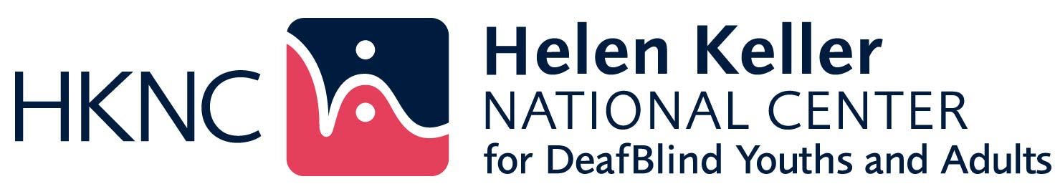

**HKNC Field Representatives Interview Synthesis**

Compiled by Megan Conway, Research and Accessibility Specialist, IRPD

October 2019

This document is a synthesis of responses from interviews conducted with HKNC Field Representatives from July to September 2019. The purpose of the interviews was to get a sense of current issues, professional development and research needs and resources in each region. The synthesis focuses on common responses mentioned in at least a third of the regions. Individual regional responses are also available.

# What is currently going on in your region?

* Vocational Rehabilitation (VR) – including conducting training on the employment needs of deaf-blind clients, coping with a lack of funding for referrals, and developing VR partnerships.
* Support Service Provider (SSP) services - particularly advocating for the establishment of services and standardizing them.
* Professional development needs – especially in general awareness about deaf–blindness, individualization, haptics, intervenor curriculum, employment, and communication.
* Regional service expansion - orientating and managing new personnel and getting approval for more staff in high need states.
* Identification – challenges associated with gathering data on the deaf-blind population and promoting understanding of the definition of deaf-blindness.

# What are the key issues for deaf-blind people in your region?

* Pro Tactile versus Haptics approaches – including issues around cultural identity, touch techniques, and “who is deaf-blind”.
* SSP services – access to SSPs and what to call them (i.e., Co-navigators, Access Providers), consistency of services, and the need for basic SSP training.
* Transportation – especially in rural areas with limited public transportation, and the connection between employment and transportation.
* Forming coalitions of deaf-blind people – the need for group advocacy to achieve action, sharing of success stories, and a lack of leadership, advocacy, and collaboration skills.
* Access to services – especially a lack of services in rural areas, interruptions in service delivery when services are all housed under one organization, the need for specialized training, the cost of services, and loss of funding for small organizations that provide needed supports.
* Employment – addressing attitudes about who can work as well as finding and maintaining work.

# What are the key issues for professionals in your region?

* Lack of research – including access to research based best practices and a lack of data.
* Lack of knowledge about deaf-blindness – the need for training in the basics of deaf-blindness, how to provide individual services, employment placement, the need for specialized training, and targeted training for VR Counselors and Job Coaches.
* Lack of money and resources – most particularly a lack of funds to go outside the state for training, large caseloads, and one-time rather than case-based professional development.

# What are some current policies, practices, or initiatives in your region?

* Interagency collaboration – particularly around transition planning, collaborations between DB projects and HKNC.
* SSP Services and Consumer Direct Services– service needs assessments, getting started with a program, which models work best.
* Customized employment – how to implement and train providers.

# What do you think are the professional development needs for HNNC staff in your region and/or nationally?

* Effective training techniques – how to effectively use online training, using Zoom, how to effectively conduct trainings and what to focus on.
* How to collaborate with different agencies – including DB Projects, VR, CILs, blindness and deafness organizations.
* Changing roles of Regional Reps – especially time management and supervising DB Specialists.

# What do you think are the professional development needs for professionals in your region?

* Basic information about deaf-blindness – such as DB 101, awareness, practical implications of working with a deaf-blind person, and etiquette.
* Employment – including placement, supports, individualization, and training of VR leadership.
* Capabilities of deaf-blind people – such as raising expectations, empowerment, and positive portrayals of deaf-blindness.

# Are there any professional development materials that you have found to be particularly helpful?

* Lack of current materials - absence of materials, need for consistent, standardized and current materials to hand out at conferences and meetings, information about what training is available and where to go, and the need for updated videos and visuals.
* Using own materials – some have gathered own materials such as journal articles, websites, periodicals, some have developed their own materials and checklists.

# What research is being done in your region?

* Pro Tactile
* Interpreters
* Intervenors
* Medical aspects of Ushers
* Need for SSPs
* Accessible health care
* Quality of life

# What research would you like to see done in your region?

* Use of Haptics in medical and care settings
* Experiences with deaf-blind label
* Integration of research findings in practice
* Written account of success stories of DB people
* Deaf-blind culture
* How deaf-blind people thrive
* Long term employment support
* Postsecondary access and professional careers
* How individualized supports lead to successful outcomes
* What constitutes successful transition planning?
* How do family and home factors influence transition?
* How do we encourage new DB leaders to step forward? How foster Grit?
* Impact of awareness program with VR and impact on services
* Use of touch on instruction and learning
* Gap between estimated and identified population
* Impact of experiences (i.e., work) beyond academics for transition age
* What is the actual impact of specific VR services for deafblind people?

# Do you have any contacts at universities or organizations in your region who might be willing to partner with us on research and/or training?

Kim Matos, U Pittsburgh (Psychiatry); Vanderbilt; UNC; UKY; University of WI State VR Research Institute; Bently University; Mich State; University in Detroit; Jennifer Lentz, LSU, Usher’s research [JLentz@lsuhsc.edu](mailto:JLentz@lsuhsc.edu); Michael Norman LSU DB Children’s program; Texas interpreter training programs; Texas Tech DB program; Austin Community College DB courses; U Arkansas at Little Rock DB Interpreting ; SSP Kathy Gabry katherinegabry@gmail.com Mark Gasaway [mark.gasaway@comcast.net](mailto:mark.gasaway@comcast.net); 2+2 Interpreter Program Kansas City Johnson CC and KU University of Montana, Ellen Condon; University of UT, Brooke Barnhill ; <http://www.cadbs.org/sdsu-cdbs-intervener-training-program>; <http://www.cadbs.org/university-cdbs-partnership-project/>; Emporia State, Kansas, grant to train Rehab counselors for Deaf/HH ; Envision blindness research, Rakesh Babu [rakesh.babu@envisionus.com](mailto:rakesh.babu@envisionus.com)