Celebrating the 12th Annual Global Accessibility Awareness Day (GAAD)
Free Webinar Presented by Helen Keller National Center

Building Up Opportunities: Inspiring Change for DeafBlind Individuals and Advocating for Accessibility

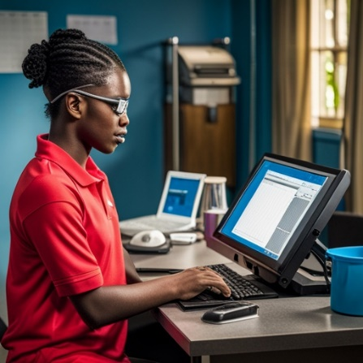

When: June 18, 2023, 2:45-3:45PM EST
Cost: Free
Join our expert panelists as they discuss:
- Strategies to value and include DeafBlind voices
- Learning from DeafBlind experiences for change
- Collaboration to work toward shared accessibility goals
- Concrete actions for accessibility and inclusion

Register now to attend

For additional questions please contact us at: WChouinard@helenkeller.org
**ASL interpretation will be provided**

