Join Our Team!
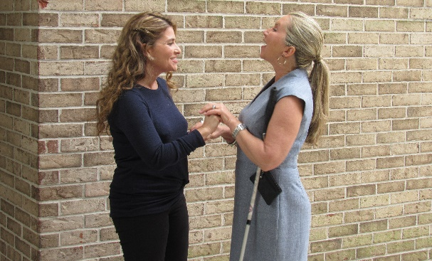

HKNC is Hiring!
Apply to become a Support Service Provider (SSP)
Training Provided for Free by HKNC

Are you interested in:
- Earning extra money while making a positive impact in the lives of DeafBlind individuals.
- Gaining experience using visual and tactile sign language
- Gaining experience working with DeafBlind individuals
- Working part-time with a flexible schedule

We are searching for motivated candidates to work as Support Service Providers for DeafBlind individuals participating in our program or employed at HKNC

What is an SSP?
An SSP (Support Service Provider) is a specially trained independent contractor who provides information and access to DeafBlind individuals which allows them to make informed decisions, participate in activities and enjoy full access to their environment and community. The main roles of the SSP include providing access to visual & environmental information, providing human guide and orientation to the environment, and facilitating communication with others.

Training Provided:
Time is running out… our next training is quickly approaching! The online self-paced portion of our training starts March 11th to March 26th (approximately 7 hours of work). The in-person training will be held at the Helen Keller National Center 141 Middle Neck Rd., Sands Point, NY 11050 on
March 25th and 26th (9AM – 4PM)

*Applications must be received before March 9th 2023!

To apply, fill out the SSP Application!

For more information:
Visit us at www.helenkeller.org or email Shernandez@helenkeller.org

