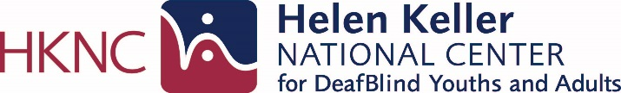

SUMMER YOUTH VOCATIONAL PROGRAM (SYVP)

Pre-Employment Services for Transition Age

HKNC works closely with schools, Vocational Rehabilitation and Blind Services programs to ensure youth who are DeafBlind benefit from services provided under the Workforce Innovation and Opportunity Act (WIOA).

HKNC’s Summer Youth Vocational Program (SYVP) will prepare you for employment and give you the confidence for starting life after high school.

At SYVP you will:
- Learn from employed mentors and peers who are DeafBlind
- Take worksite tours and meet hiring managers
- Create your work portfolio and participate in practice interviews
- Understand your personal interests and strengths
- Learn from leaders who are DeafBlind how they applied advocacy to success in college
- Develop work readiness skills for personal care, managing meals, budgeting, travel and telecommunications to be successful at work
- Develop an action plan to meet your goals!

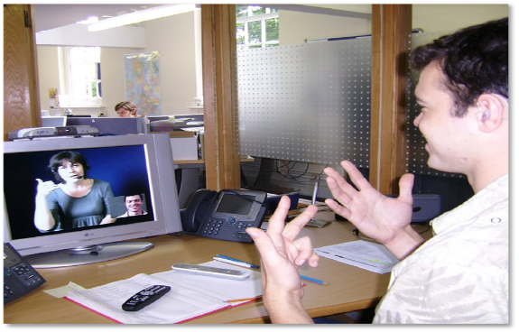

Come join your peers ages 16-24 from around the country to learn skills that lead to
employment success.

Session I: June 5, 2023 - July 14, 2023 (Application deadline: April 7, 2023)

Session II: July 17, 2023 - August 25, 2023 (Application deadline: May 5, 2023)

It’s not ALL work! There will be time in the evening and on the weekends to join in recreational activities, travel to New York City, participate in community outings and socialize with peers and staff.

Contact your Regional Representative to find out how you can apply:
https://www.helenkeller.org/hknc/nationwide-services

HKNC SYVP Consumer 10/13/2021

